**Face Mask Detection Analysis**

**On**

**Python**

**Submitted to**

**LOVELY PROFESSIONAL UNIVERSITY**

in partial fulfilment of the requirements for the award of degree of

**Master of Computer Applications**

**Supervised By**

**Submitted By**

**MD IMRAN KUMAR VISHAL**

**REGD NO - 12115224 SCA**

**LOVELY FACULTY OF TECHNOLOGY & SCIENCES**

**LOVELY PROFESSIONAL UNIVERSITY**

**PUNJAB**

**(17 November 2022)**

|  |  |  |
| --- | --- | --- |
| **Table of Content** | | |
| ***Sr. No.*** | ***Content*** | ***Page Index*** |
| 1 | Introduction and Objective |  |
| 2 | Screen Shots with coding [Including Database table] |  |
| 3 | Validation Checks |  |
| 4 | Testing (Testing techniques and Testing strategies) |  |
| 5 | Future scope of the project |  |

**INTRODUCTION**

Object detection is a computer vision approach for detecting and locating objects in images and video. Object detection can detect instances of visual objects of specific classes such as persons, animals, cars or buildings in digital pictures like photos or video frames. When an image is shown to the eyes, the brain immediately recognizes the objects. On the other hand, a machine needs a long time and a lot of training data to recognize the images. However, due to the development of recent technology in machine learning, deep learning and the field of computer vision has become a lot easier and more intuitive. Object detection technology has exploded in popularity across a wide range of sectors. It enables self-driving cars in safely navigating traffic, detecting violent behavior in crowded areas, monitoring object through video surveillance, recognizing face mask through object detection module, ensuring adequate quality control of pars in production, among many other things. And this is only the tip of the iceberg in terms of what object detection technology can achieve! In modern video surveillance systems, detecting faces in video streams is a critical task. Deep learning algorithms have recently been developed that deliver face identifying results.

**OBJECTIVE**

Face mask detection refers to detect whether a person is wearing a mask or not. In fact, the problem is reverse engineering of face detection where the face is detected using different machine learning algorithms for the purpose of security, authentication and surveillance. Face detection is a key area in the field of Computer Vision and Pattern Recognition.

A significant body of research has contributed sophisticated algorithms for face detection in the past.

**Screenshot of Codding (using Notepad++ with .py Concept)**

Its code detects the mask video when camera on

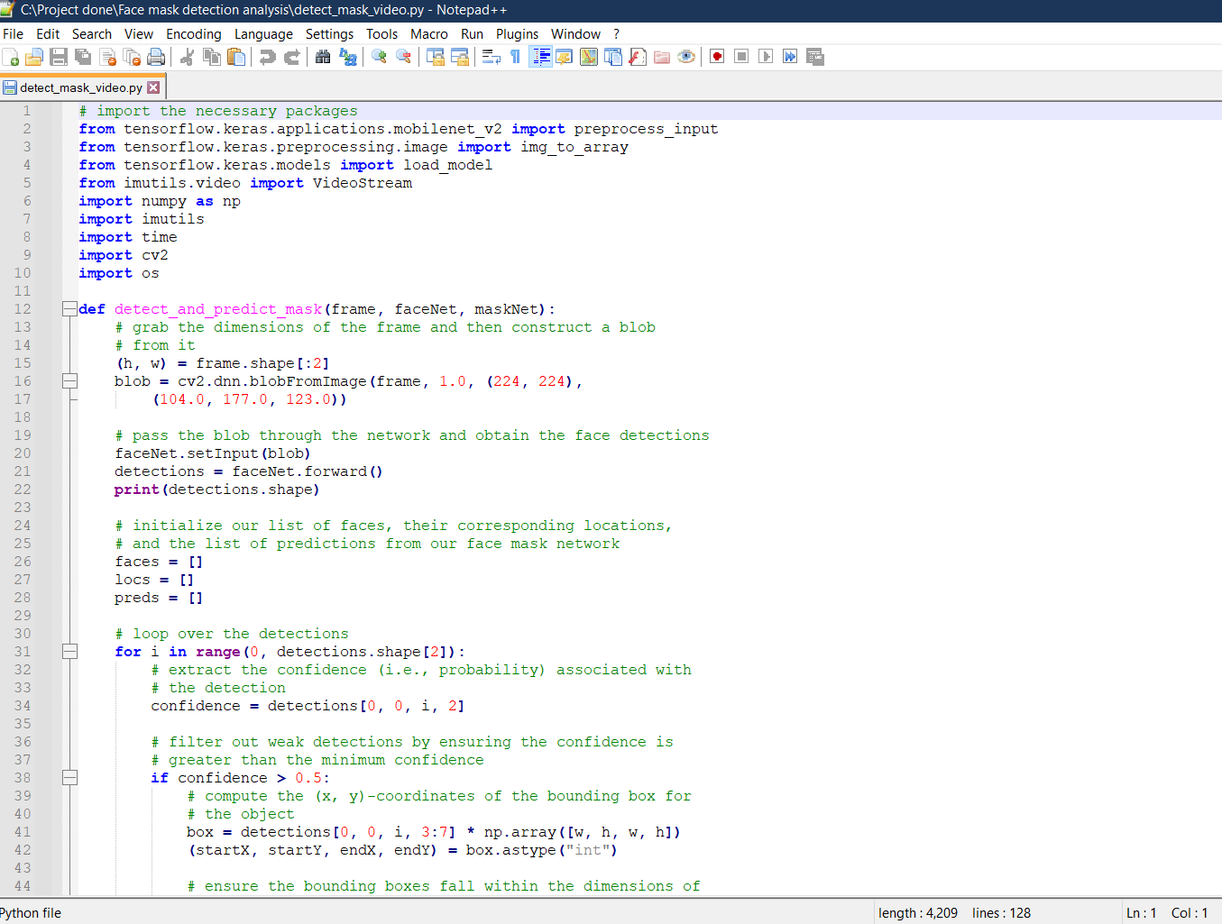

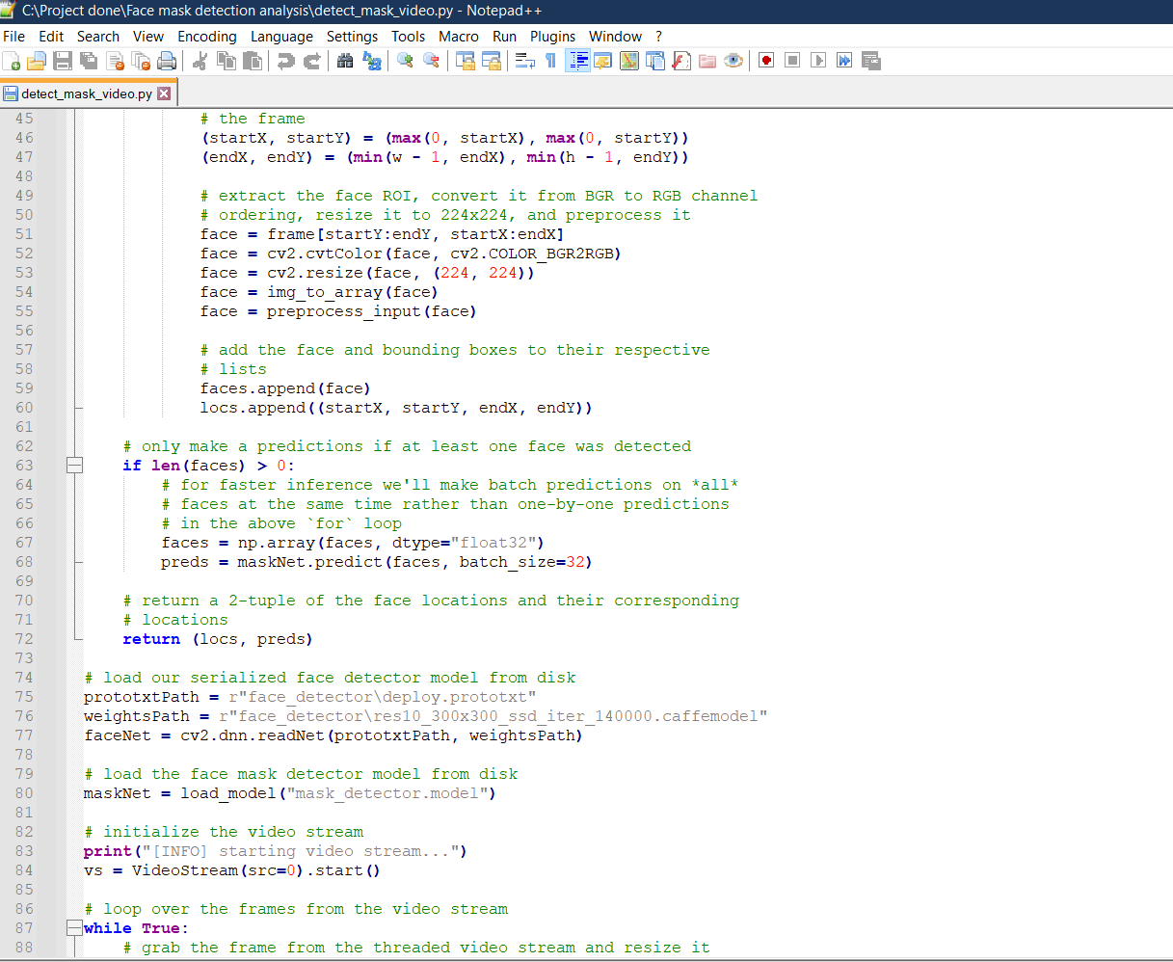

**Train the code:**



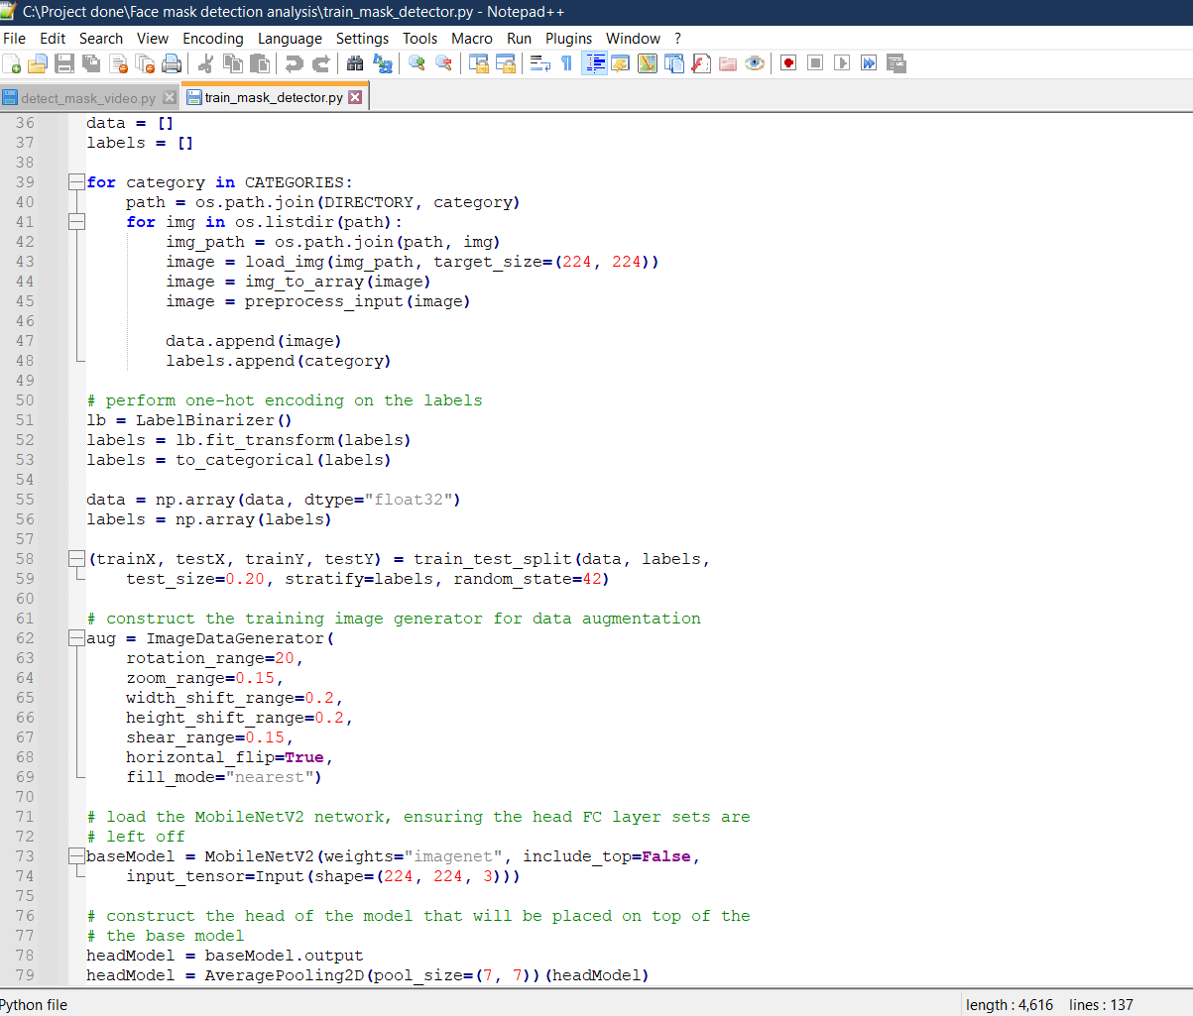

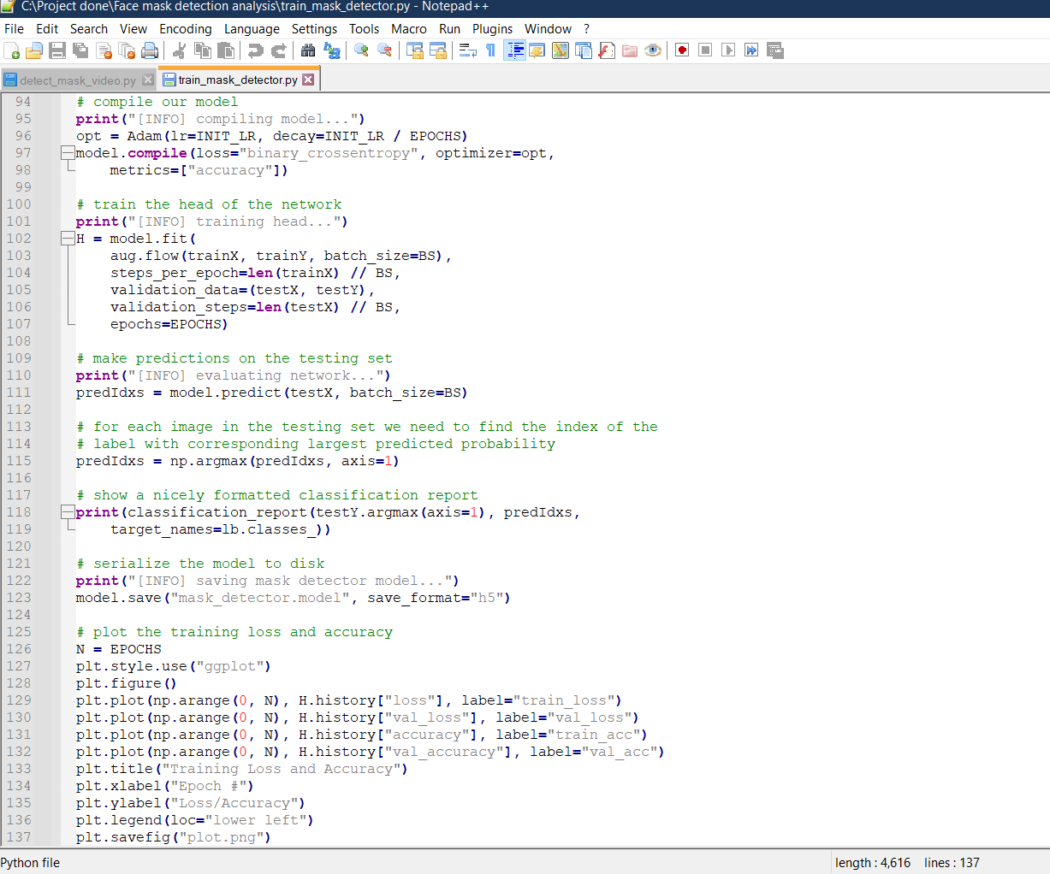

**3.Validation Checks**

**NOT VALID CHECKS (**Wrong Symbol Images | Free Photos, PNG Stickers, Wallpapers & Backgrounds -  rawpixel**)**

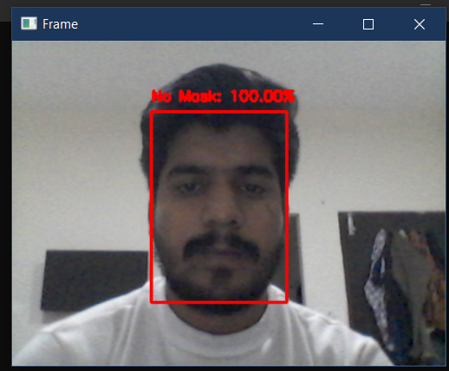

**VALID CHECK (** **)**

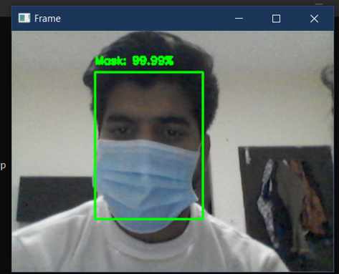

5.Future scope

In this work, a deep learning-based approach for detecting masks over faces in public places to curtail the community spread of Coronavirus is presented. The proposed technique efficiently handles occlusions in dense situations by making use of an ensemble of single and two-stage detectors at the pre-processing level. The ensemble approach not only helps in achieving high accuracy but also improves detection speed considerably. Furthermore, the application of transfer learning on pre-trained models with extensive experimentation over an unbiased dataset resulted in a highly robust and low-cost system. The identity detection of faces, violating the mask norms further, increases the utility of the system for public benefits.

Finally, the work opens interesting future directions for researchers. Firstly, the proposed technique can be integrated into any high-resolution video surveillance devices and not limited to mask detection only. Secondly, the model can be extended to detect facial landmarks with a facemask for biometric purposes.